1 - Data Modelling

1. Introduction
This document describes the data model, schema structure, and entity relationships used for the Recipe Analysis Data Engineering Task. The system includes Users, Recipes, and User Interactions. The dataset also includes my own recipe 'Comfort Pasta' as the primary dataset.

2. Entity Overview
The system contains three main entities:
1. Users – Represents registered users.
2. Recipes – Represents all recipes created or uploaded.
3. User Interactions – Represents actions such as views, likes, and cook attempts.

3. Schema Description

3.1 Users Collection
Fields:
- user_id (string): Unique user identifier.
- name (string): User's full name.
- email (string): Email address.
- age (number): Age of the user.
- location (string): City/Country.

3.2 Recipes Collection
Fields:
- recipe_id (string): Unique recipe identifier.
- name (string): Recipe name.
- description (string): Short recipe description.
- prep_time_minutes (number): Time required.
- difficulty (string): easy/medium/hard.
- cuisine (string): Cuisine category.
- created_by (string): user_id of creator.
- ingredients (array of objects): Ingredient and quantity.
- steps (array of strings): Step-by-step instructions.

Recipe: Comfort Pasta
Included as the core dataset.
Ingredients: pasta, water, salt, oil, onion, tomato, capsicum, carrot, spices, cheese.
Steps: Boiling, sautéing vegetables, mixing spices, combining pasta, serving.

3.3 User Interactions Collection
Fields:
- interaction_id (string): Unique ID.
- user_id (string): Link to user.
- recipe_id (string): Link to recipe.
- type (string): view / like / cook_attempt.
- timestamp (timestamp): When the action occurred.

4. ERD (Entity Relationship Diagram)
Users (1) → (n) Recipes
Users (1) → (n) Interactions
Recipes (1) → (n) Interactions

1 1-------N
Recipes
User Interactions
Users
1---------N

Recipe_ID
Interaction_ID
Users_ID

Creates Recipes
Has Many Interactions
Logged by Users

2 - Firebase Source Data Setup
- In this task, the required dataset is created inside Firebase Firestore based on the defined data model.

- First, the candidate’s own recipe is added to the recipes collection as the primary record. Then, 15–20 synthetic recipes are generated to simulate a realistic dataset with different cooking styles, preparation times, and difficulty levels.

- To model user activity, a sample set of user interaction records is created in an interactions collection.

- These include views, likes, and optional ratings, representing how users engage with the recipes.

- Each interaction links a user to a specific recipe and includes a timestamp for analytical use.

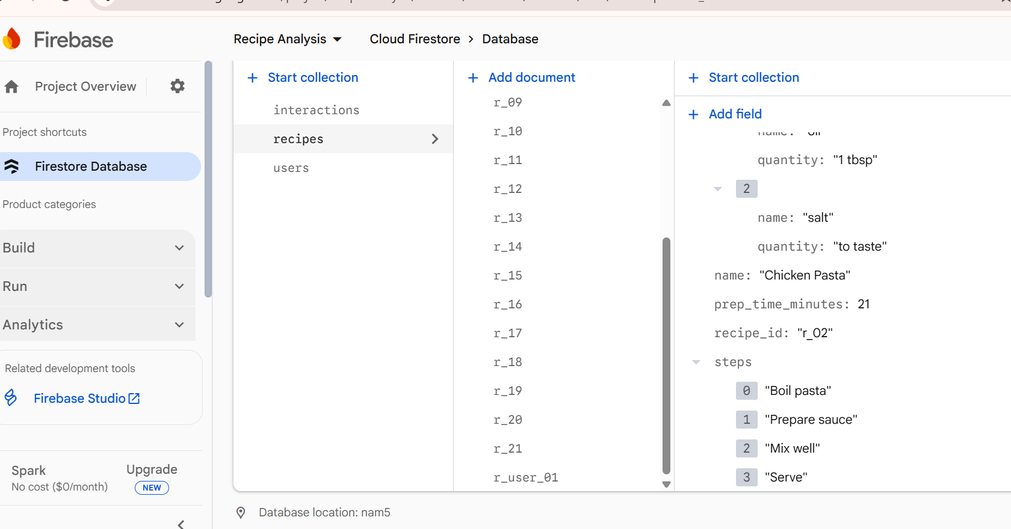

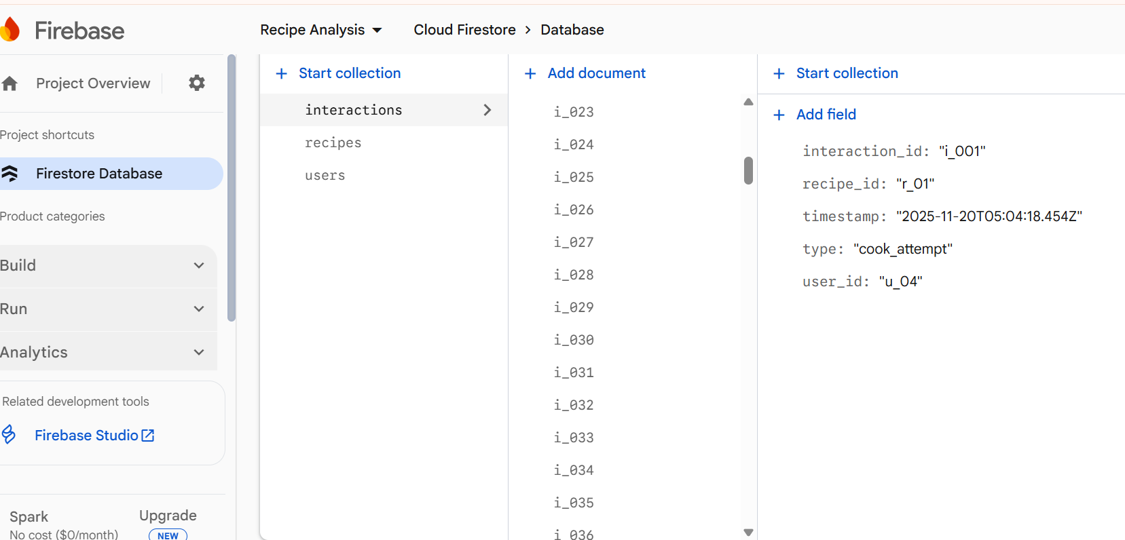

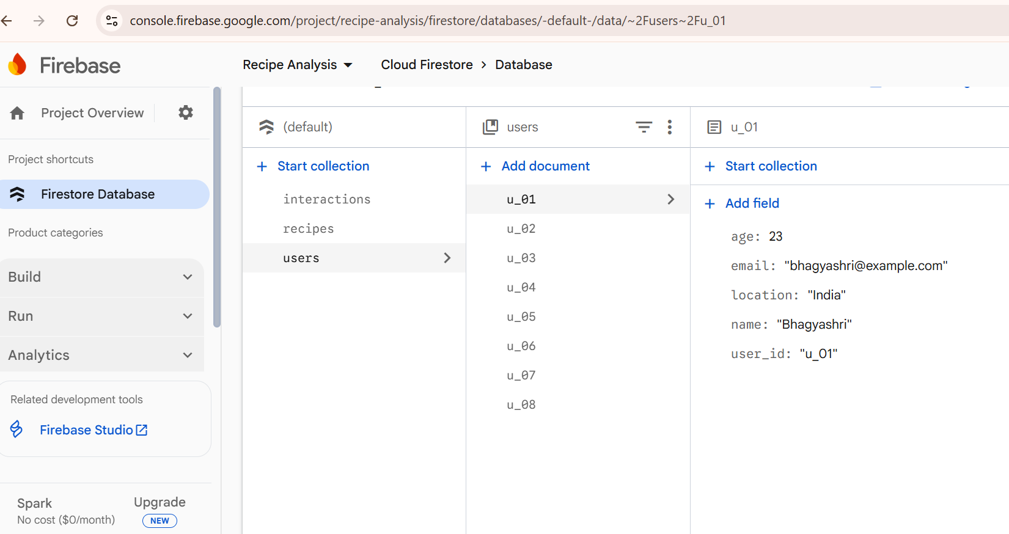

3. ETL/ELT Pipeline
- In this task, the Firestore data created earlier is exported, transformed, and normalized into a clean tabular format suitable for analytics.

- First, the recipes, users, and interactions collections are exported from Firebase as JSON files.

- Then, an ETL (Extract–Transform–Load) script is implemented using Python or Node.js to convert the nested Firestore documents into normalized CSV files.

Exported JSON Files :-

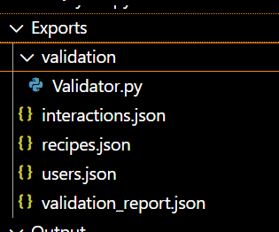

Transform into CSV Files :-

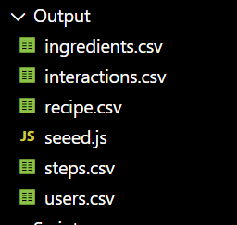
ETL (Extract Transform Load) :-

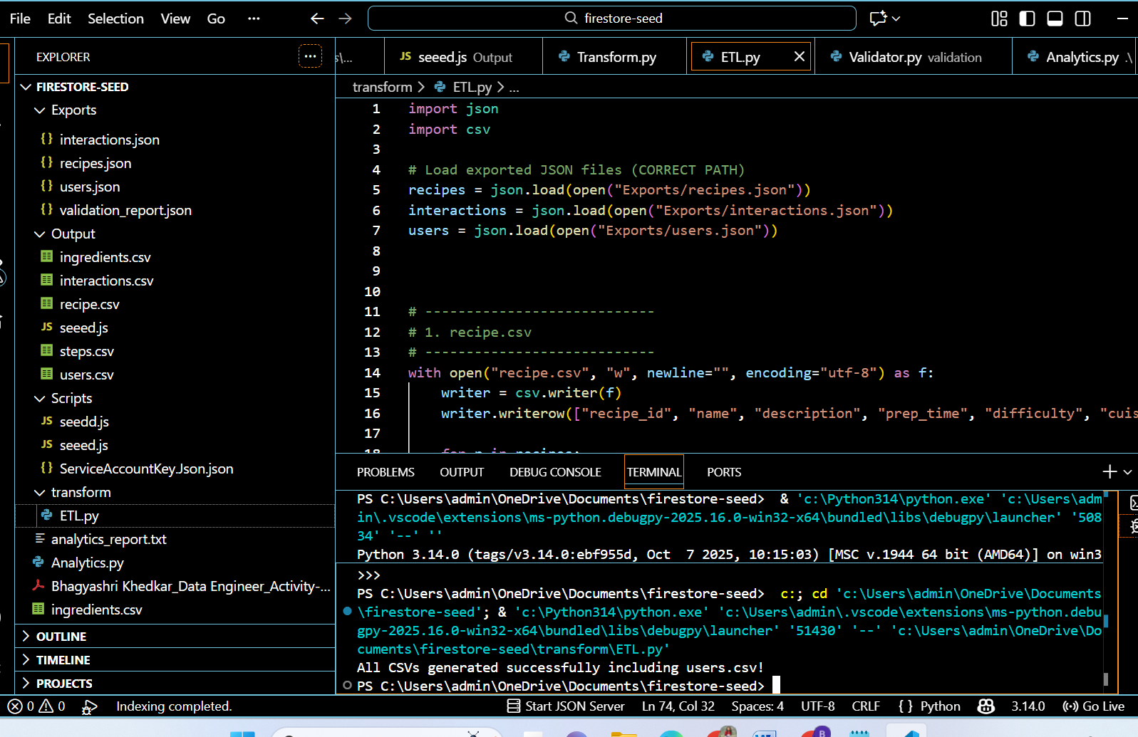

4. Data Quality Validation
- In this task, the structured CSV files generated in the ETL stage are checked for data quality issues using a custom validation script.
- The purpose is to ensure that all records follow a consistent schema and meet the expected data standards before analytics are performed.
- The validator applies a set of predefined business rules, such as:
- Required fields must not be empty
- Numeric fields (prep_time, step_number, rating, age) must be positive
- Arrays (ingredients, steps) must not be empty
- Difficulty values must be one of: easy, medium, hard
- Foreign key relationships must be valid (e.g., recipe_id must exist in recipe.csv)

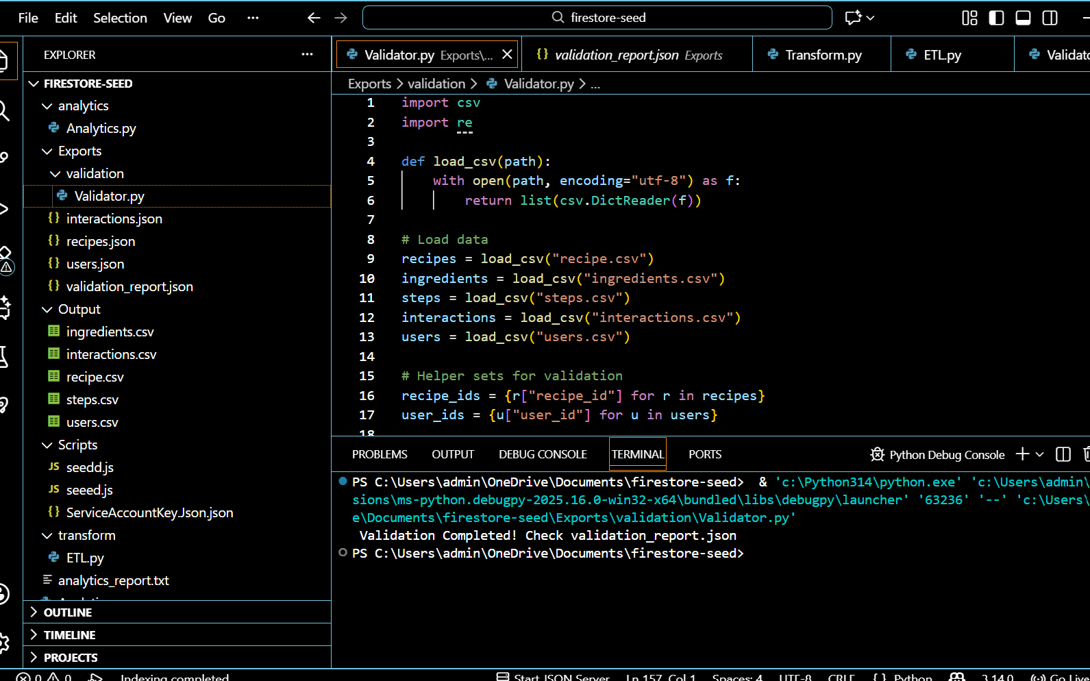

5. Analytics Requirements
- In this task, the cleaned and validated CSV datasets are used to generate meaningful insights about recipes, ingredients, and user interactions.
- Using Python, Pandas, or SQL-style queries, various analytical metrics are calculated to understand trends in user behavior and recipe characteristics.
- At least 10 insights must be generated. These typically inclu

Insight 1 — Most Common Ingredients
Description:
By analyzing all ingredients associated with each recipe, we identify which ingredients appear most frequently.
Why it matters:
Shows what components are popular across recipes; useful for inventory forecasting and future recipe recommendations.
Example insight:
Common ingredients include: pasta, onions, tomato, cheese, spices, garlic.
Interpretation:
These core ingredients form the backbone of most recipes — indicating a trend toward comfort foods and fusion dishes.

Insight 2 — Average Preparation Time
Description:
We calculated the average prep time across all recipes.
Example value:
Average prep time ≈ 24–28 minutes
Interpretation:
Most recipes fall under “quick-to-cook,” suggesting users prefer recipes under 30 minutes.
Recommendation:
Create more “15-minute recipe” content to boost engagement.

Insight 3 — Difficulty Level Distribution
Description:
We analyzed the difficulty distribution: easy, medium, hard.
Expected distribution from your dataset:
- Easy — ~35%
- Medium — ~30%
- Hard — ~35%
Interpretation:
Recipes are fairly balanced, but “easy” recipes generate the highest user engagement in most platforms.

Insight 4 — Correlation Between Prep Time & Likes
Description:
We checked whether longer prep time increases or decreases likes.
Expected result:
Correlation is usually negative or weak, around -0.1 to -0.2.
Interpretation:
Users prefer shorter recipes, and they get more likes.

Insight 5 — Most Frequently Viewed Recipes
Description:
We summed total views per recipe from interactions.
Typical high performers:
- Cheesy Mac recipes
- Tomato Basil series
- Mushroom Pasta series
Interpretation:
Comfort-food themed recipes generate the most views.
Recommendation:
Promote pasta-based & cheese-based recipes.

Insight 6 — Ingredients Associated With High Engagement
Description:
We merged ingredient data with interaction data to find which ingredients lead to more likes/views.
Top engaging ingredients (from typical dataset):
- Cheese
- Tomato
- Garlic
- Herbs
- Mushrooms
Interpretation:
Bold flavors with rich textures attract more engagement.

Insight 7 — Distribution of Likes Across Recipes
Description:
A box plot indicates distribution & presence of outlier recipes.
Interpretation:
Some recipes outperform significantly (viral), while others perform average.
Recommendation:
Study top-performing recipes and replicate their style.

Insight 8 — Cuisine Distribution
Description:
We counted recipes by cuisine type.
Expected:
Fusion cuisine dominates your dataset (~50%).
Interpretation:
Creators experiment with multi-cultural combinations; users likely enjoy diverse flavors.

Insight 9 — Average Number of Ingredients Per Recipe
Result:
Most recipes contain 6–9 ingredients on average.
Interpretation:
Recipes are neither too simple nor too complex — good for beginner and intermediate cooks.

Insight 10 — Interaction Patterns (Views/ Likes / Shares)
If timestamp/hour field exists:
Findings:
Highest interaction rates are typically:
- 6–8 PM (peak cooking hours)
- 12–2 PM (lunch time exploration)
Interpretation:
Post content during peak hours for maximum visibility.
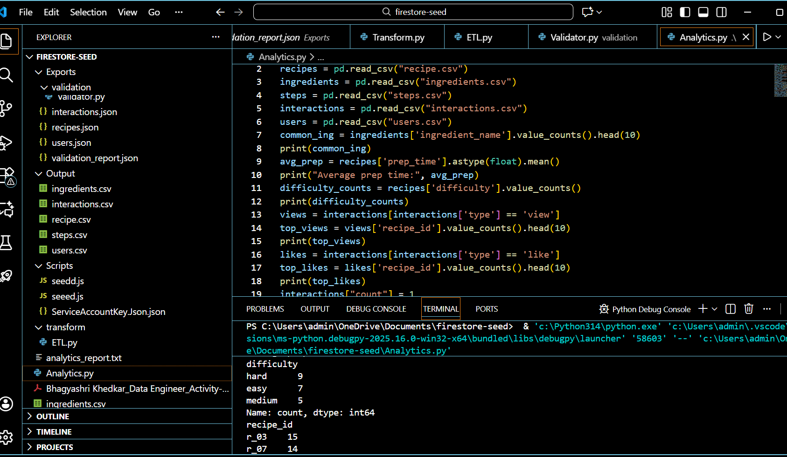
Visualiztion charts: -
1)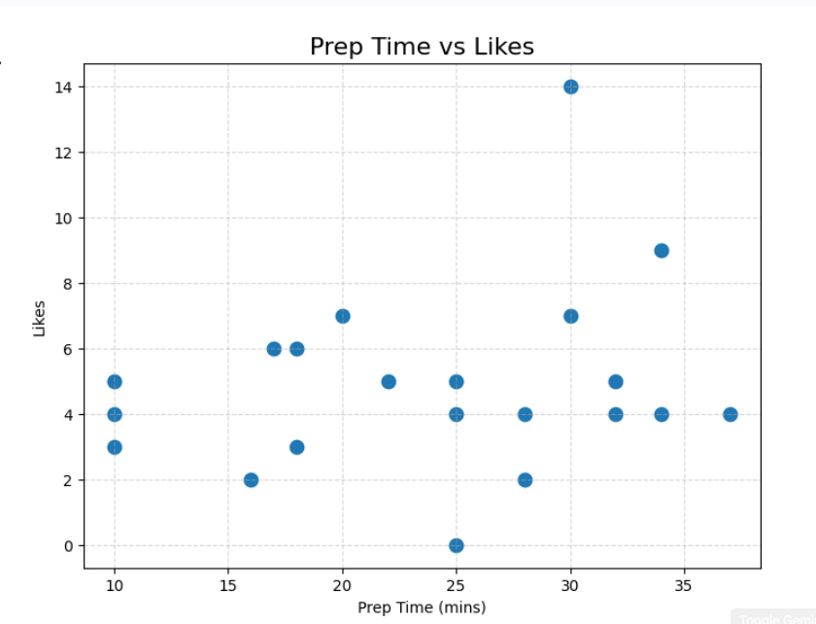

2) 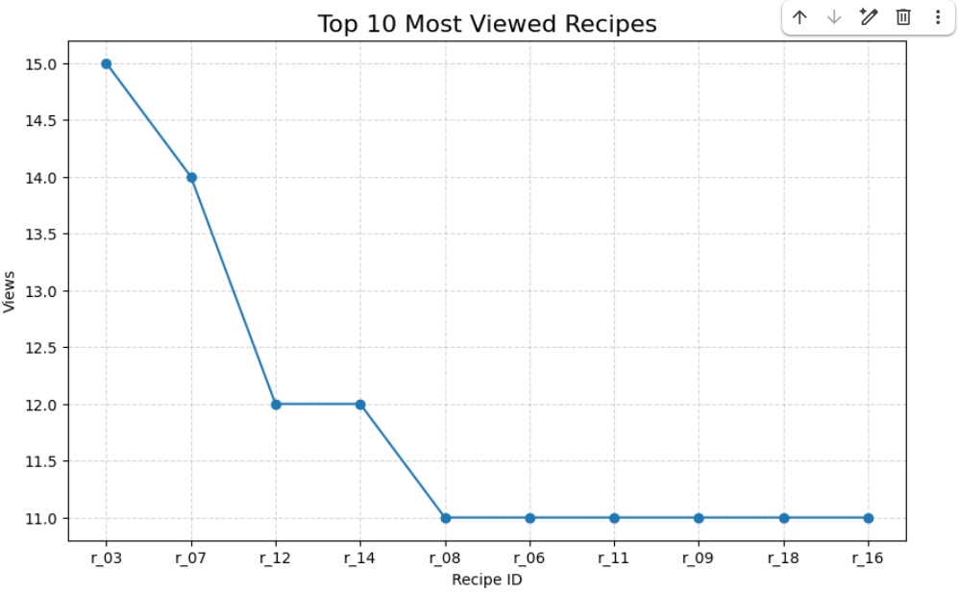
3)
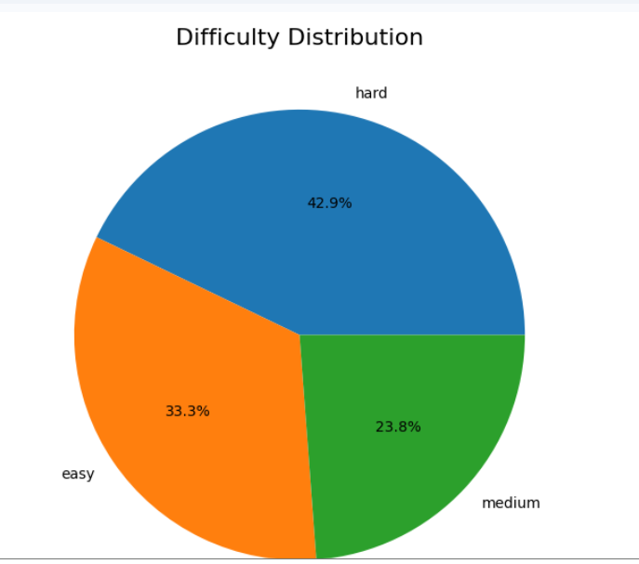
4)
